PRAYER SUPPORT FOR YOU AND YOUR FAMILY
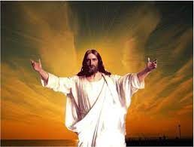
My friend, how is your spiritual strength?
Do you know that your spiritual strength to a greater extent determines your natural well-being?
Most people focus only on what is visible to the exclusion of the unseen realm?
Here is a misleading phrase – what you cannot see can’t hurt you
Friend, many have sustained injuries in life including emotional, financial, and many injuries because they did not realize they first sustained spiritual injuries. Others are seeking only physical solutions for spiritually initiated attacks on their lives. Yet others have been spiritually indicted resulting in physical complications in their lives.
That is why it is most important to commit your life/ family into the Omnipotent hands of God. This is best done through spiritual prayers under the Power of the Holy Spirit of God.
Christ said: (And I will ask the Father, and He will give you another Advocate to be with you forever— the Spirit of truth. Jn 14:16-17)
Pastor Edward invites you/family to Messiah Hour
Pastor Edward has prayed for many in different countries to receive spiritual victories
Join Pastor Edward on Saturdays 8AM EST in Messiah Hour on
ZOOM ID# 985 751 5009
RSVP FOR FIRST TIMERS PLEASE TEXT: 714-473-8202

